# <Project Name>

Quality Management Plan

Version 1.0

Contents

Revision History 3

Overview 4

Methodology 4

Quality Assurance 4

Quality Control 5

Project Audits 5

Roles & Responsibilities 5

Product Testing 6

Documentation Review 6

Escalation 7

Metrics 7

Compliance and Certification 7

Schedule 8

Approvals 8

APPENDIX A - Quality Plan Audit Log 9

## Revision History

|  |  |  |  |
| --- | --- | --- | --- |
| **Date** | **Version** | **Author(s)** | **Notes** |
| 14/05/2020 | 1.0 |  |  |
|  |  |  |  |
|  |  |  |  |
|  |  |  |  |
|  |  |  |  |

## Overview

Provide an overview of the quality management strategy the project will apply to ensure deliverables meet the expectations of sponsors, stakeholders, end-users, and other clients. Include an outline of the process or methods to be applied to ensure continuous improvement, prevention of non-conformities, and track and address customer satisfaction concerns. This strategy will guide the project team to the standards they need to follow to ensure success of the project.

Remove this comment section from the final document.

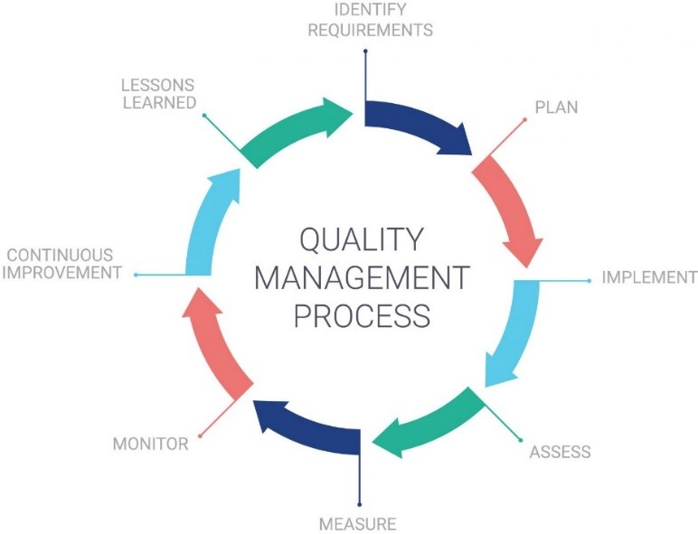

## Methodology

Provide an overview of the project quality management methods to be applied to meet the quality management strategy detailed above.

Remove this comment section from the final document.

Quality Assurance

QA is the set of activities the project team will pursue to ensure quality in the processes by which products are developed. QA aims to prevent defects with a focus on the process used to make the product. It is a proactive quality process. The goal of QA is

to improve development and test processes so that defects do not arise when the product is being developed. Verification is an example of QA. Provide an overview of the planned quality activities for the project.

Remove this comment section from the final document.

### 

### Quality Control

Quality Control (QC) is the set of project activities for ensuring quality in products. These activities focus on identifying defects in the actual products produced. QC aims to identify (and correct) defects in the finished product. Quality control, therefore, is a reactive process. The goal of QC is to identify defects after a product is developed and before it's released. Validation/Software Testing is an example of QC.

Remove this comment section from the final document.

### 

### Project Audits

Project auditing is the processes for conducting detailed inspection of the management of a project, its methodology, its techniques, its procedures, its documents, its properties, its budgets, its expenses, and its level of completion. Project audits of projects may be conducted at the transition from one phase of a project to another. A project audit is a key step in the process of closing a project. The closing audit evaluates the total project processes and outcomes and is required for all projects. Provide an overview of the project audit plan, including general schedule and key areas to be audited. Use the Quality Audit Log template in Appendix A for tracking audit non-conformities.

Remove this comment section from the final document.

## 

## Roles & Responsibilities

List the primary roles of the project staff as it relates to the practice of project Quality Management. Indicate point-of-contact and contact email.

Remove this instruction text from the final document.

|  |  |  |
| --- | --- | --- |
| **Quality Role** | **Point of Contact** | **Contact Email** |
| **e.g., QA Manager** |  |  |
| **e.g., Test Leader** |  |  |
| **e.g., UAT Coordinator** |  |  |
|  |  |  |
|  |  |  |

### Product Testing

The QA team is responsible for identifying and preventing the unintended release of product components or features that do not conform to project requirements or client expectations. This process is conducted through Quality Reviews and Testing. List the key product deliverables contained in the project plan that will be subject to a QA review upon completion in the project timeline.

Remove this comment section from the final document.

### 

### Documentation Review

List the key project documentation deliverables the QA team will be responsible for reviewing.

Remove this comment section from the final document.

|  |  |  |  |
| --- | --- | --- | --- |
| **#** | **Project Document Deliverables** | **Milestone Date** | **Comments** |
| **1** | Project Charter |  |  |
| **2** | Project Schedule |  |  |
| **3** | Work Breakdown Structure (WBS) |  |  |
| **4** | Quality Management Plan |  |  |
| **5** | Risk Management Plan |  |  |
| **6** | Communications Management Plan |  |  |
| **7** | Change Management Plan |  |  |
| **8** | Training Plan |  |  |
|  |  |  |  |

|  |  |  |  |
| --- | --- | --- | --- |
| **#** | **Project Document Deliverables** | **Milestone Date** | **Comments** |
|  |  |  |  |

### Escalation

Define the escalation path for unresolved quality noncompliance issues both internal and external to the project. Provide an overview of the escalation process the QA team will follow for managing project quality. Detail any dependencies or prerequisites required to meet for each level of escalation.

## Metrics

Quality Metrics must be defined, collected, and analyzed to facilitate the monitoring of program/project objectives. Detailed metric data gathering is conducted by the QA team and delivered to the Project Manager for key QA tasks and activities to identify trends, reflect performance, and highlight issues for resolution and problem avoidance. These metrics should be reviewed regularly during status meetings and on an ad-hoc basis as urgency requires. Examples of metrics to be gathered are document issues, code defects, testing defects, and operations defects. Define the Quality Metrics that will be collected and presented by the QA team to the Project Manager for project status reporting.

Remove this comment section from the final document.

## 

## Compliance and Certification

Detail any compliance or certification requirements that must be met before the solution can become operational (i.e. Federal or State statue’s, conditional standards, etc.).

Remove this comment section from the final document.

## Schedule

Provide an overview of critical quality management milestones with dependencies that interface with the Project Manager’s project schedule.

Remove this comment section from the final document.

## Approvals

|  |  |  |  |  |
| --- | --- | --- | --- | --- |
| Identify by name, title, and signature the individuals agreeing to authorize expenditure of organizational resources to accomplish the project activities. At a minimum, the Quality Management Plan should be signed by the Project Manager, the Project Sponsor, the Quality Assurance Lead and, if applicable, the Executive Sponsor.  Remove this comment section from the final document. | | | | |
|  | **Role** | **Name & Title** | **Signature** | **Date** |
|  |  |  |  |  |
|  |  |  |  |  |
|  |  |  |  |  |
|  |  |  |  |  |
|  |  |  |  |  |

## APPENDIX A - Quality Plan Audit Log

List all quality-related issues and resolutions resulting from quality plan audits and reviews.

Remove this comment section from the final document.

|  |  |  |  |
| --- | --- | --- | --- |
| **Planned Quality**  **Review Date** | **Activity Reviewed** | **Issue(s)** | **Resolution** |
|  |  |  |  |
|  |  |  |  |
|  |  |  |  |
|  |  |  |  |
|  |  |  |  |
|  |  |  |  |
|  |  |  |  |
|  |  |  |  |